Time series
Procedure for SARIMA modeling

1. Plot the data. Transform? Outliers? Differencing?
- Plot Y ~ time, maybe find outliers or try log transformation
- Get date into desired format for modeling
- Plot Y~ month to check seasonality

2. Difference to find d, D.
- Difference to remove trend, find d.
- Then difference to remove seasonality, find D.

3. Examine acf and pacf of differenced series.
- Find P and Q first, by examining just at lags s, 2s, 3s, etc.
- Find p and q by examining between seasonal lags.
- Could use function auto.arima() to give some advice in R-- library(forecast).
- SAS has PROC FORECAST could help, choose the STEPAR method, it will fit the best autoregressive model.

4. Fit SARIMA(p, d, q)x(P, D, Q)s model to original data.
- Try several SARIMA (p, d, q)x(P, D, Q) model around the select model.
- Compare models using AIC, BIC, try to select a model with few parameters

5. Check model diagnostics
- Check correlation of residuals
- QQ plot
- Residuals with time, month, day

6. Forecast (back transform?)

SARIMA (p, d, q)x(P, D, Q). The idea is that SARIMA are ARIMA(p,d,q) models whose residuals are ARIMA(P,D,Q).

library(forecast)
auto.arima(ts(deaths$rate, freq = 12))
“auto.arima” in SAS?
You might want to give PROC FORECAST a try. PROC FORECAST that lets you forecast many series at once pretty quickly. And if you choose the STEPAR method, it will fit the best autoregressive model it can find to your data.

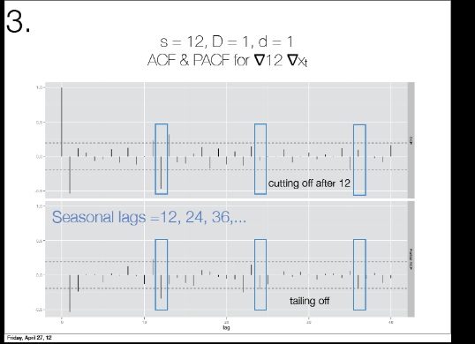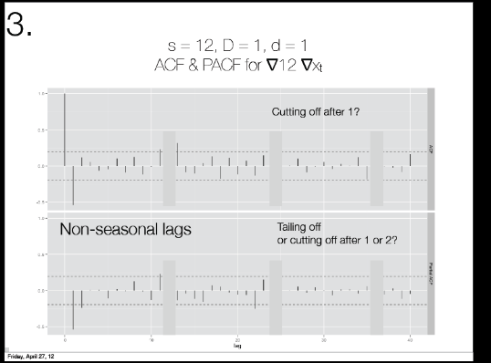

R code for Time series:
library(plyr)
library(ggplot2)
library(reshape)
library(lubridate)
options(stringsAsFactors = FALSE)
#code for examine_corr
source(url("http://stat565.cwick.co.nz/code/get_acf.R"))
source(url("http://stat565.cwick.co.nz/code/fortify-ts.r"))
big_font <- theme_grey(base_size = 24)

# == read in and tidy data == #
load(url("http://stat565.cwick.co.nz/data/deaths.rda"))
head(deaths)
#write.csv(deaths, file="d:/deaths.csv")
qplot(date, deaths , data = deaths , geom = "line")+geom_smooth() + big_font
deaths $rate <- deaths$deaths/deaths$reg
head(deaths)
qplot(date, reg , data = deaths , geom = "line")+ geom_smooth() + big_font
qplot(date, rate , data = deaths , geom = "line") + geom_smooth() + big_font

# clean up our data so that is has all the dates and is in order.
all_days <- data.frame(date = seq(ymd("1994-01-01"), ymd("2010-12-31"), by = "day"))
# redo years, months and ydays
deaths $year <- year(deaths $date)
deaths $month <- month(deaths $date)
deaths $yday <- yday(deaths $date)
# force it to be in order
deaths <- deaths [order(deaths $date), ]
qplot(month , rate , data = deaths ) +big_font
# showing seasonality
########################################################################
# taking first differences removes the trend
deaths$diff <- c(NA, diff(deaths$rate))
qplot(date, diff, data = deaths, geom = "line") +
big_font

# Remove strong seasonality
# could also remove the seasonality by differencing
# 12 months per year, so difference at lag 12 in original data
# taking first differences removes the trend
deaths$diff_12 <- c(rep(NA, 12), diff(deaths$diff, lag = 12))
qplot(date, diff_12, data = deaths, geom = "line") +
big_font

# the trend is gone, but the variation looks like it decreases, try log transform
deaths$diff_12_log <- c(rep(NA, 12), diff(log(deaths$rate), lag = 12))
qplot(date, diff_12_log, data = deaths, geom = "line") +geom_smooth()+
big_font
#write.csv(deaths, file="d:/deaths_log_season_trend.csv")

# orignal plot with log transform
qplot(date, log(rate), data = deaths, geom = "line") +
big_font

# so the first difference and remove seasonality looks stationary in mean, but what about variance
qplot(date, diff_12_log^2, data = deaths) +
geom_smooth() +
big_font

# looks stationary, let's choose an ARMA(p, q) model
acf(deaths$diff_12_log, lag.max = 36, na.action = na.pass)
# significant at lag 12
pacf(deaths$diff_12_log, lag.max = 36, na.action = na.pass)
# significant at lag 12
#Better to remove seasonality

library(forecast)
# need to make it a ts to get seasonality
auto.arima(ts(deaths$diff_12_log, freq = 12))
#ARIMA(2,0,0)(2,0,0)[12] with zero mean
########################################################################
#try automatic procedure

library(forecast)
# need to make it a ts to get seasonality
auto.arima(ts(deaths$rate, freq = 12))
#ARIMA(1,1,1)(2,0,2)[12]
(fit_sarma10 <- arima(deaths$rate, order = c(2, 0, 0), seasonal = list(order = c(2, 1, 1), period = 12)))
(fit_sarma11 <- arima(deaths$rate, order = c(0, 1, 1), seasonal = list(order = c(2, 1, 1), period = 12)))
(fit_sarma12 <- arima(deaths$rate, order = c(2, 1, 0), seasonal = list(order = c(0, 1, 1), period = 12)))

(fit_sarma <- arima(deaths$rate, order = c(1, 0, 1), seasonal = list(order = c(2, 0, 2), period = 12)))
(fit_sarma1 <- arima(deaths$rate, order = c(1, 1, 1), seasonal = list(order = c(2, 0, 2), period = 12)))
(fit_sarma2 <- arima(deaths$rate, order = c(0, 1, 1), seasonal = list(order = c(2, 0, 2), period = 12)))
(fit_sarma3 <- arima(deaths$rate, order = c(1, 1, 0), seasonal = list(order = c(2, 0, 2), period = 12)))
(fit_sarma4 <- arima(deaths$rate, order = c(1, 1, 1), seasonal = list(order = c(1, 0, 2), period = 12)))
(fit_sarma5 <- arima(deaths$rate, order = c(1, 1, 1), seasonal = list(order = c(0, 0, 2), period = 12)))
(fit_sarma6 <- arima(deaths$rate, order = c(1, 1, 1), seasonal = list(order = c(2, 0, 1), period = 12)))
(fit_sarma7 <- arima(deaths$rate, order = c(1, 1, 1), seasonal = list(order = c(2, 0, 0), period = 12)))
(fit_sarma8 <- arima(deaths$rate, order = c(1, 1, 1), seasonal = list(order = c(2, 1, 2), period = 12)))
#ARIMA(1,0,1)(2,0,2)[12]
# picks ARIMA(1,0,1)(2,0,2)[12]

# diagnostics
examine_corr(residuals(fit_sarma ))
last_plot()+ big_font

qqnorm(residuals(fit_sarma))
qqline(residuals(fit_sarma))

qplot(yday, residuals(fit_sarma), data = deaths) +geom_smooth()
qplot(month , residuals(fit_sarma), data = deaths) +geom_smooth()
# mean looks flat

qplot(date, residuals(fit_sarma), data = deaths) + geom_smooth()

n <- nrow(deaths)

pred.df2 <- as.data.frame(predict(fit_sarma, n.ahead = 4, newratereg = (n+1):(n+4)))
pred.df2$date <- max(deaths$date) + (0:3)/4

qplot(date, rate, data = deaths, geom = "line") +
geom_ribbon(aes(ymin = exp(pred- 2*se), ymax = exp(pred + 2*se), y = NULL), data = pred.df2, alpha = 0.2) +
geom_line(aes(y = exp(pred)), data = pred.df2) +
opts("using auto.arima model")
detach()
SAS code for time series (part of code)
ods graphics on;
/* Read data*/
proc import datafile="d:/deaths.csv"
out=deaths
DBMS=CSV REPLACE;
run;
PROC SGPLOT DATA = deaths;
SCATTER X = date Y = deaths;
RUN;
PROC SGPLOT DATA = deaths;
SCATTER X = month Y = deaths;
RUN;
proc transreg DATA = deaths;
model identity(deaths) = smooth(date / sm=50);
output p out= deaths_smooth;
run;

****************************************************************;
/*Fit model and forecast in original data*/
proc arima data=deaths;
identify var=deaths(1,12);
estimate q=(1)(12) noint method=ml;
forecast id=date interval=month printall out=b;
run;
/*Some code in Forecast statement*/
proc forecast data=past interval=month lead=10
method=expo trend=2
out=pred outfull outresid
outest=est outfitstats;
var sales;
id date;
run;

